I know there are plenty of turbo install walkthroughs already. But with the release of the BNR hybrid turbos I thought this might help the numerous members purchasing these new turbos.
Because I already have a FMIC I am skipping the removal of the TMIC and starting with the turbo exposed. If you need instructions on removal of the TMIC please search.
I also changed the oil and coolant so my motor was dry during the swap. You do not have to do this. You wil lose very minimal oil (drops) and if you clamp off the coolant supply and return hoses you will lose minimal drops) of coolant too.
Pic 1=
The objective. You can see the top side turbo to downpipe bolts. You need to remove the two bolts on top and the nut on the passenger side.
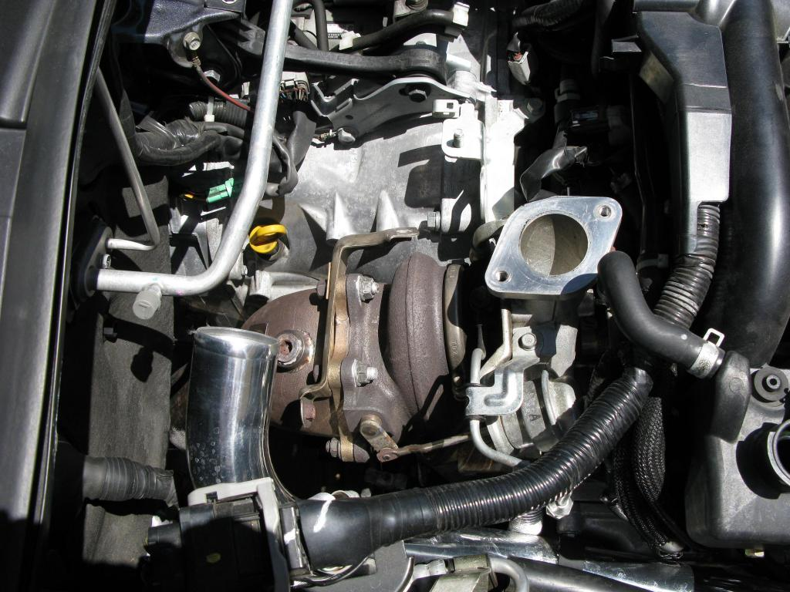
Pic 2=
The bottom side turbo to downpipe studs. You need to remove the bottom nut and the drivers side nut.
All are accessible from the top except the very bottom nut (under the bell housing). Use some PB Blaster to assist in removal. If replacing the heatshield note the orientation of the bracket.
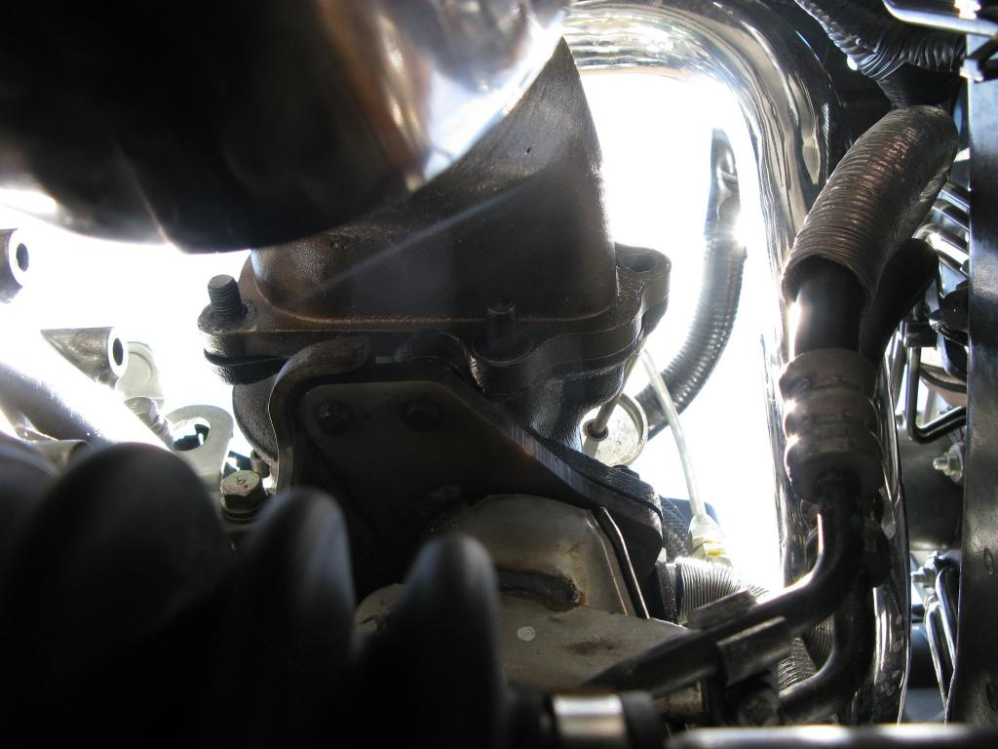

Pic 3=
The downpipe hanger connection to the tranny. You will need to remove this.
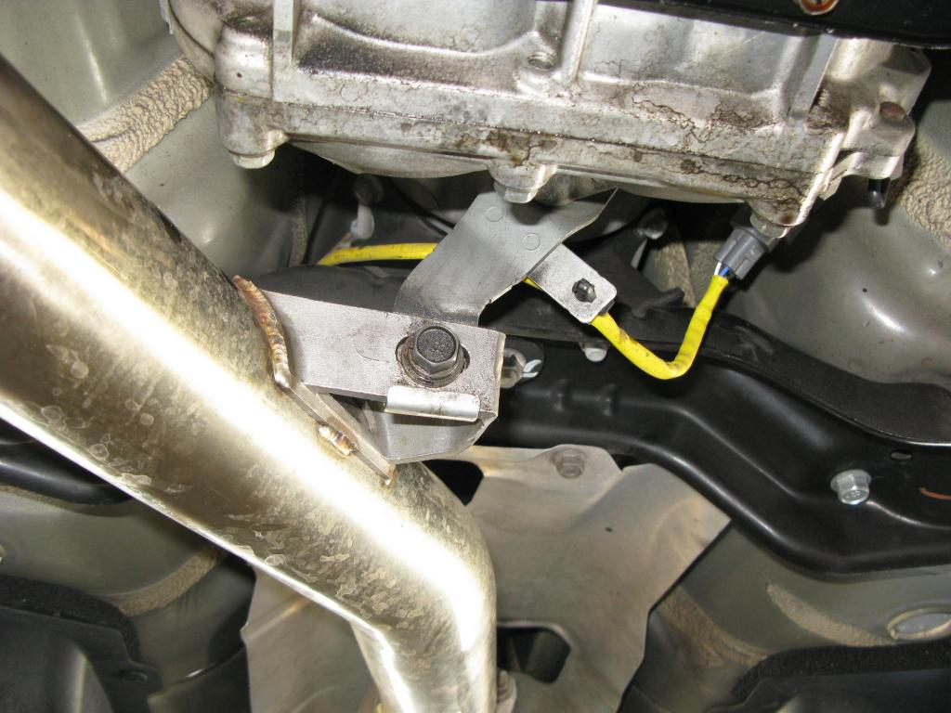
Pic 4=
The O2 sensor connection. Easiest to remove the plug here and leave the O2 in the pipe.
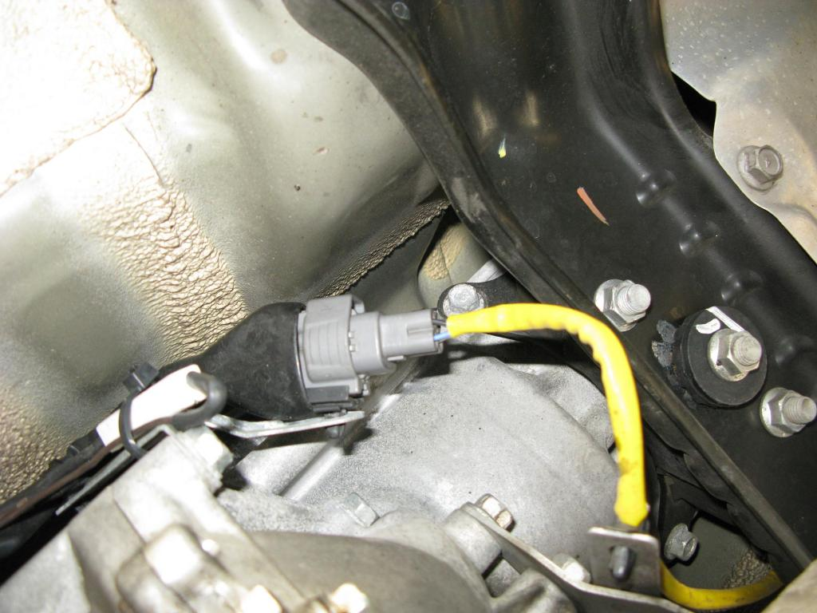
Pic 5=
The bottom connection of the turbo oil return line. Note the orientation of the hose and clamp. I marked mine with lines on top and bottom. Best to release the clamp and let it fall on the tube.
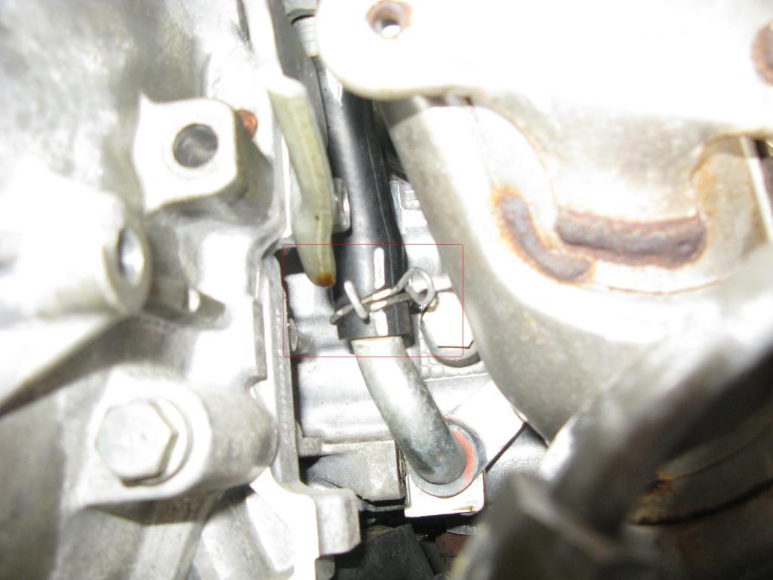
Pic 6=
The top connection of the turbo oil return hose. You cant get to it. Leave it alone. When you pull the turbo up the hose will still be attached to the turbo.
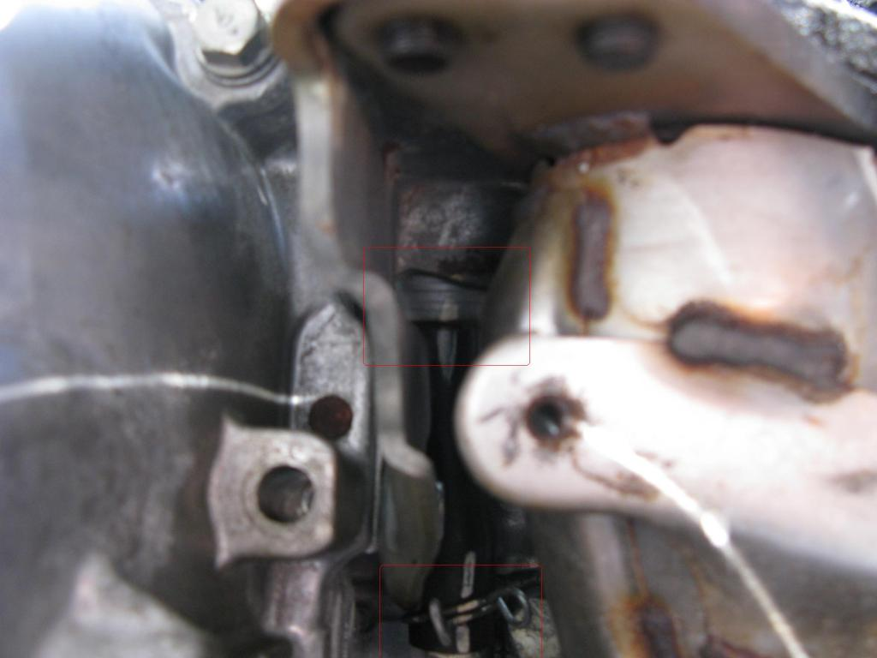
Pic 7=
The first uppipe to turbo bolt. PB Blaster again and remove.
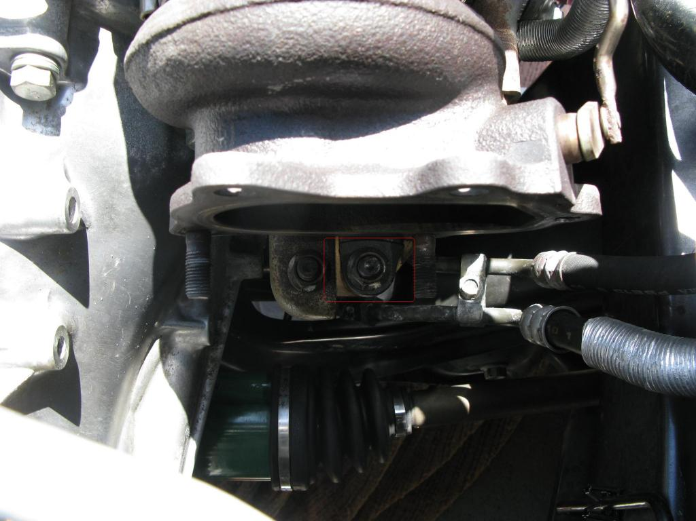
Pic 8=
Another angle.
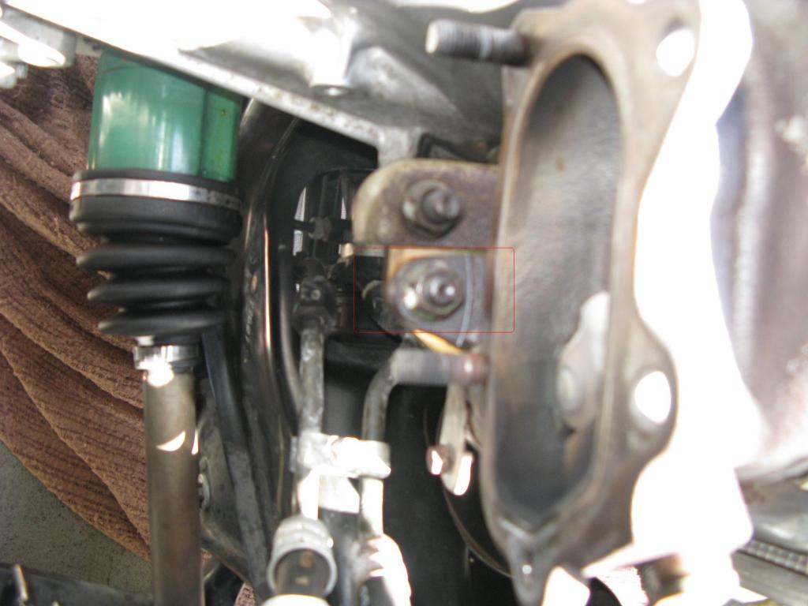
Pic 9=
The last two uppipe to turbo bolts. You need to remove these two as well.
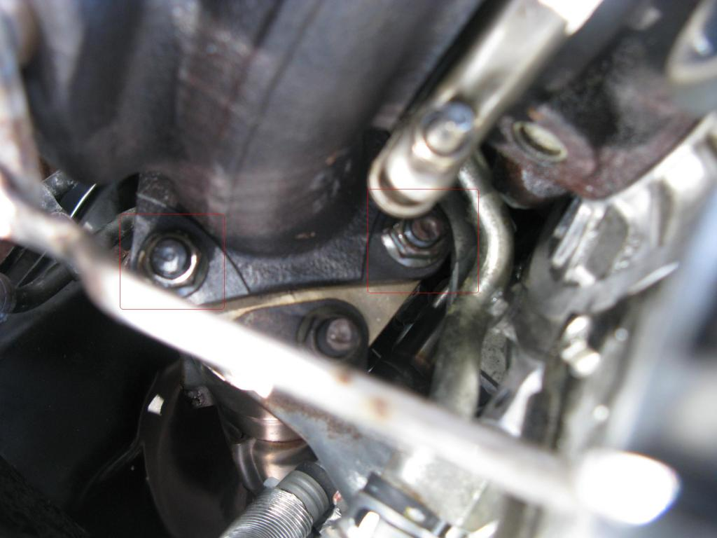
Pic 10=
The flare fitting of the oil line. Use two wrenches on one top and one on bottom. Hold the bottom in place and break the top loose. It is tight. Be careful not to bend the pipe, it will break.
Q: Regarding the flare fitting on the turbo oil supply (http://legacygt.com/forums/attachmen...8&d=1276831368) I am using 2 17mm wrenches to loosen it, but nothing is moving. Any tips?
A: It is very tight from the factory. Try some PB Baster. Then hold the bottom very steady (no turning) and loosen the top. It will take a lot of force (more than you really might think you should apply). It will "snap" when it gives. Then it will be loose. Every turbo swap I have done this was an issue. I chalk it up to the Subaru torque gorilla at the factory.
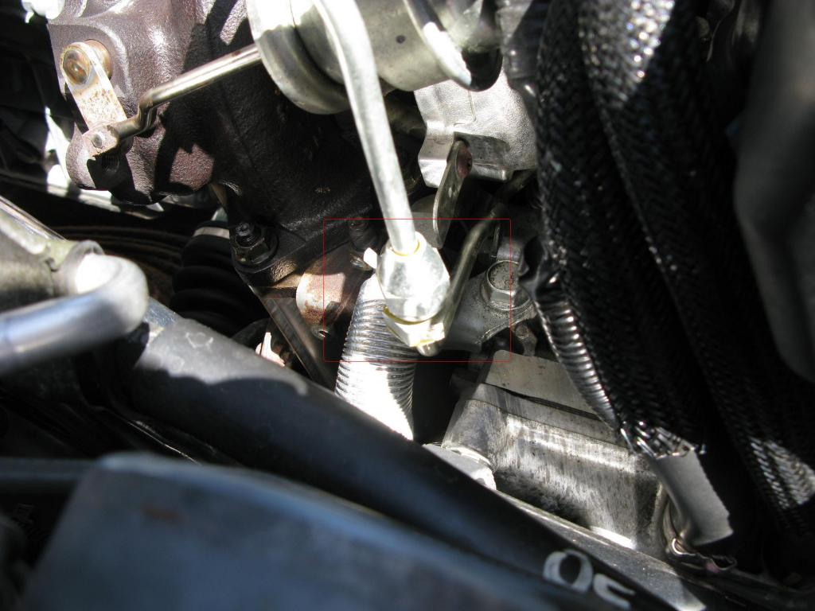
Pic 11=
The oil line fitting and the coolant return hose. If clamping this hose be careful, the heat coating will probably crack at the least. No big deal.
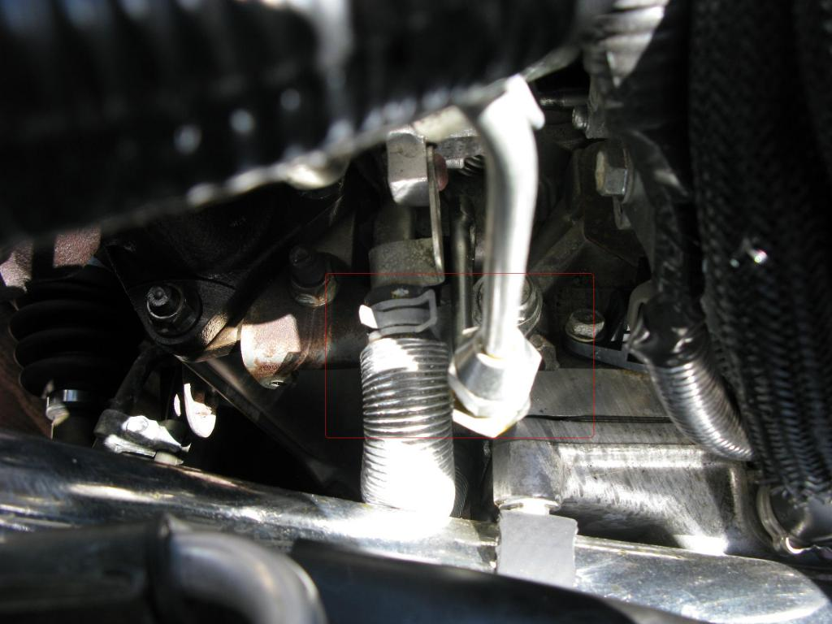
Pic 12=
The coolant supply hose . You can clamp it off and remove from the turbo only.
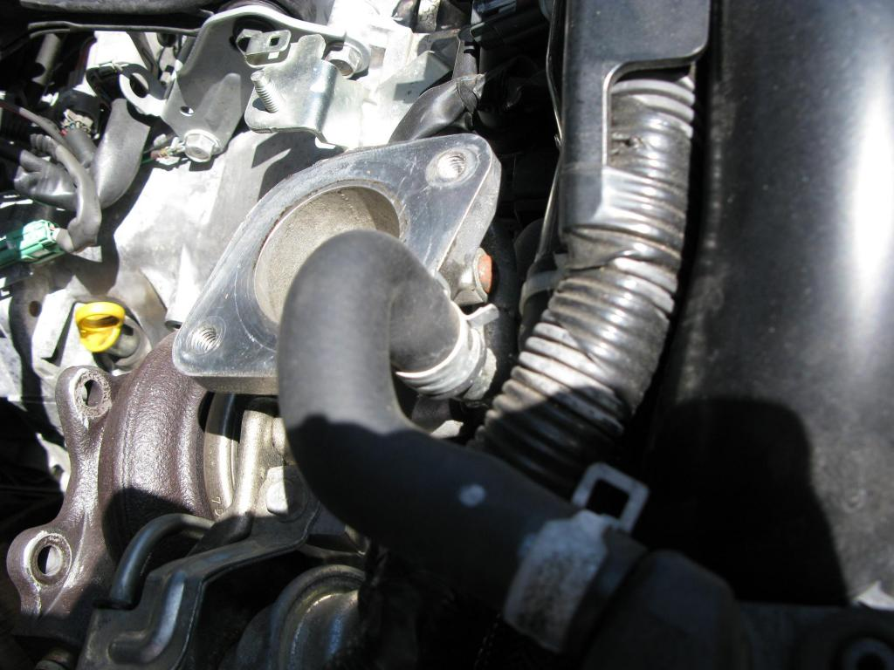
Pic 13=
Coolant hoses removed, oil line removed.
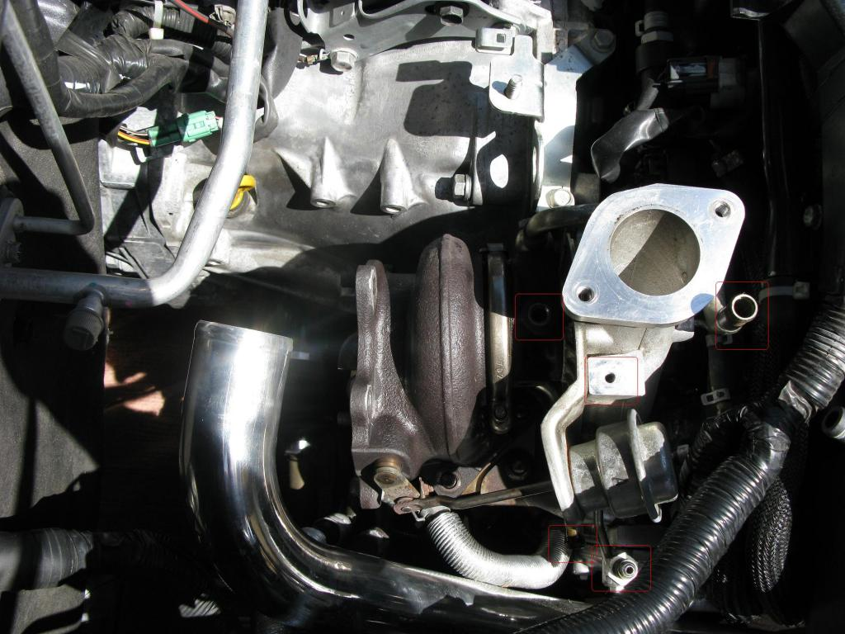
Pic 14=
Another angle. Just need to release the clamp on the turbo inlet now and pull of the vacuum hoses.
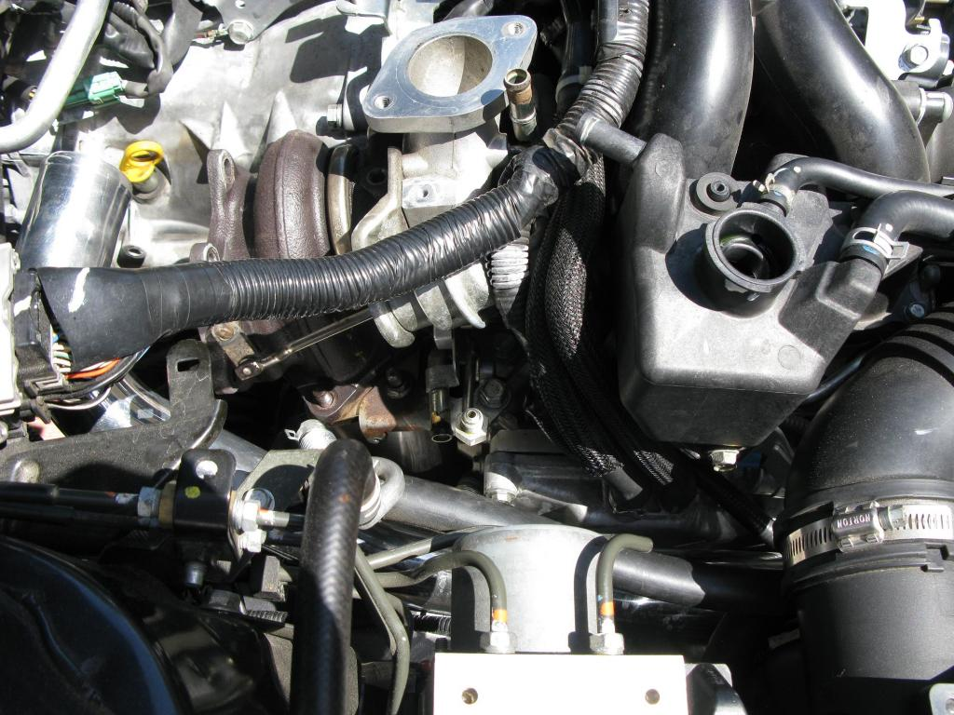
Pic 15=
Turbo out. Just pull back and then straight up. Remember you are pulling the hose off the bottom pipe too. It might resist a little.
I also circled the "infamous" banjo bolt with filter. This is a 2008. On earlier models it was on the side instead of the top. Remove this banjo bolt. Then use a pick and remove the filter from inside the bolt. Replace.
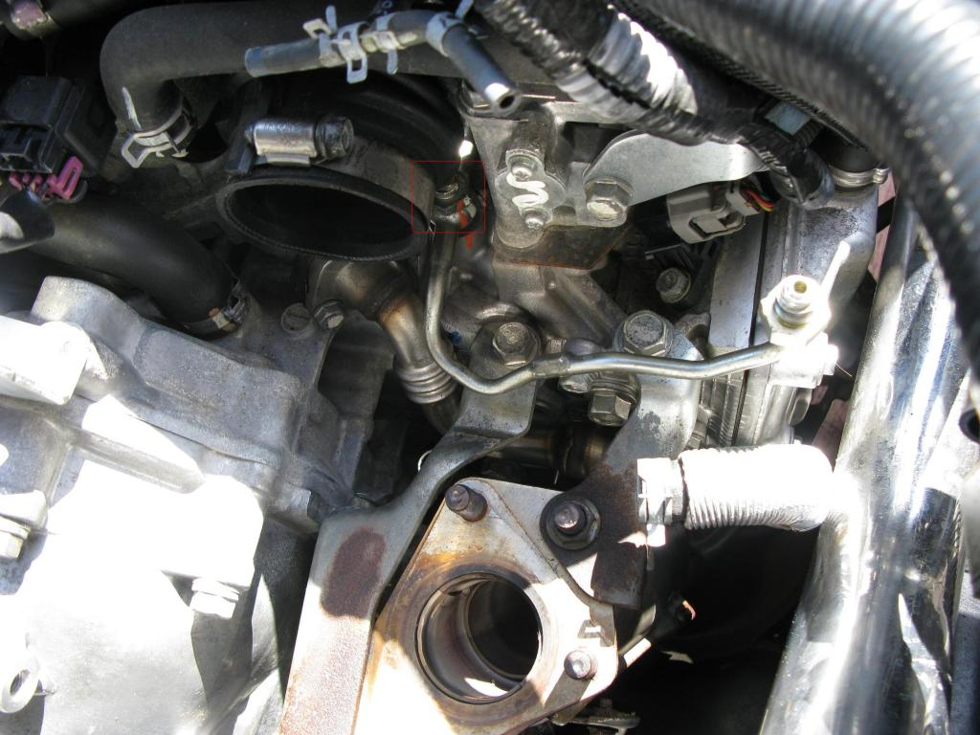
Pic 16=
My trick to install the new turbo with no tools on the inlet. Put your gasket on the uppipe, remove the hex bolt holding the inlet tube in place, then use string or zip ties (like I did) wrapping around the inlet and the manifold.
The inlet faces a bit down. The turbo needs to go over the studs and onto the oil return line while going into the inlet all at the same time. If you release the inlet it has some play. Use the ties to hold the inlet up so that the "mouth" is slightly tilted up. You are lifting it as far as possible.
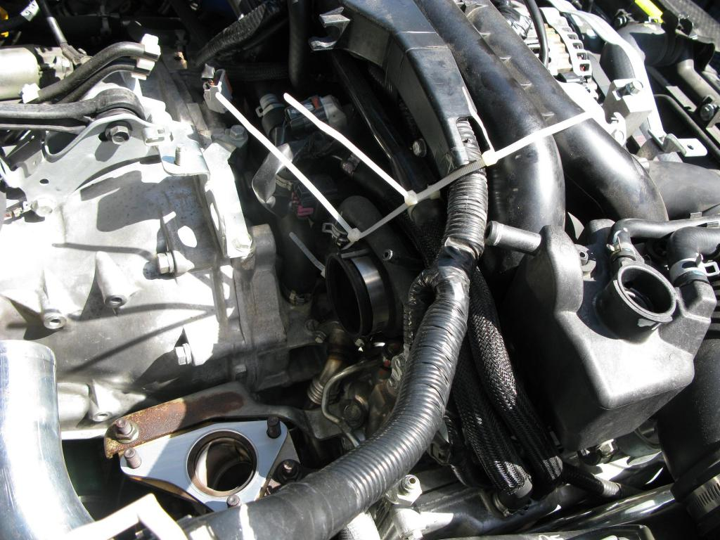
Pic 17=
Another angle of my zip ties.
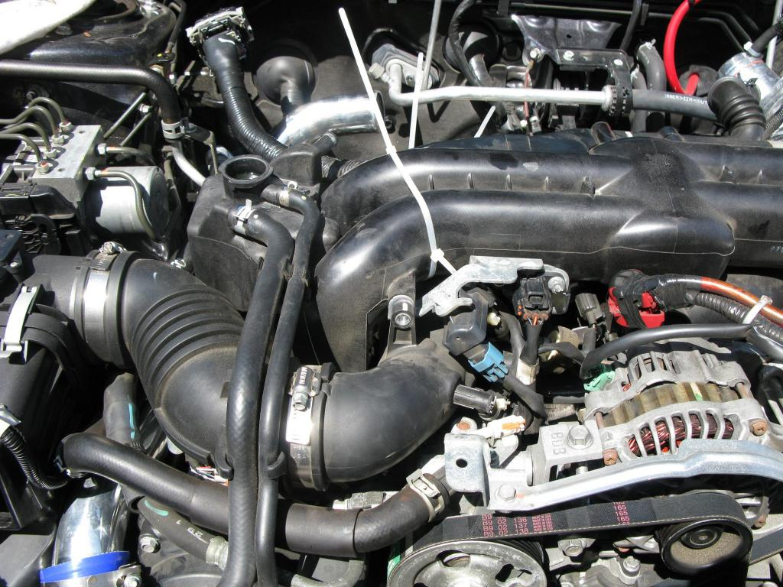
Pic 18=
The turbo dropped back in. The oil line was mounted to the turbo before install. The coolant lines and oil line were checked for torque too. The oil return hose was attached in the same position as it came off.
When installing I rest the turbo on the uppipe studs from the top. I go underneath and align the oil return hose and tube. You can get the hose to just set a bit on the pipe with the turbo beginning to go onto the studs. From the top I drop the turbo over the studs while angling in the inlet. A little angle and wiggle and it will go in to the inlet as it falls over the studs and onto the oil return tube. You might have to do it a few times, be patient it will work. A second set of hands is a huge help, but I usually do it alone. If the inlet is sticking use a little motor oil on the inside of the inlet. It will help.
Once the turbo is sitting in place you can cut the zip ties and pull them out. Then torque down the turbo (3 bolts), I like to use some anti-seize on all the turbo to uppipe and downpipe bolts.. Then tighten the clamp on the inlet and replace the inlet hex bolt.
Go underneath and lift the spring clamp back onto the oil return hose now. Too
TIP: I have a "trick" I use for the pesky oil return line. I either cut a longer piece of new hose (easier) or if reusing OEM here is what I do. OEM has a paint mark on it designating orientation. Note this when removing OEM turbo. Place hose on new turbo in exact same orientation. Use worm gear or similar clamp on turbo side. Use OEM spring clamp on bottom side. Set spring clamp on lower tube. It will fall to the turn in the tube. When installing the turbo be sure the hose lines up. When you push the turbo down the hose will start (if not go all the way on, a little motor oil helps for lube). If hose is not all the way seated, pull it down with hose pliers. Then use needle nose and grab the lower spring clip. Lift it up onto the hose. Done. Low pressure. Should not leak.
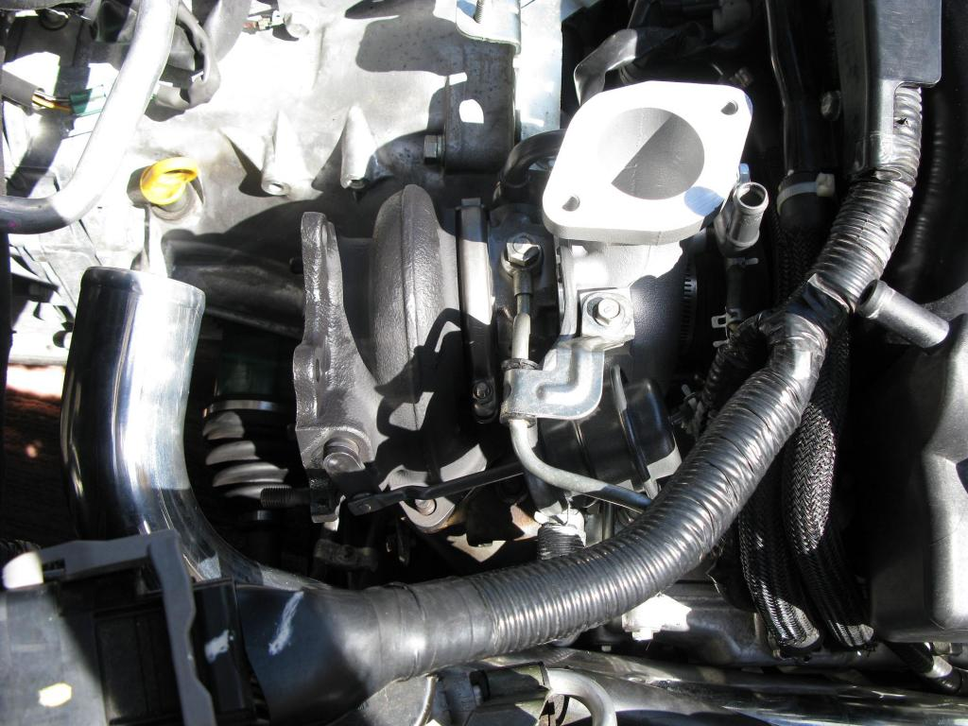
Pic 19=
Oil line tightened back down and coolant return hose replaced.
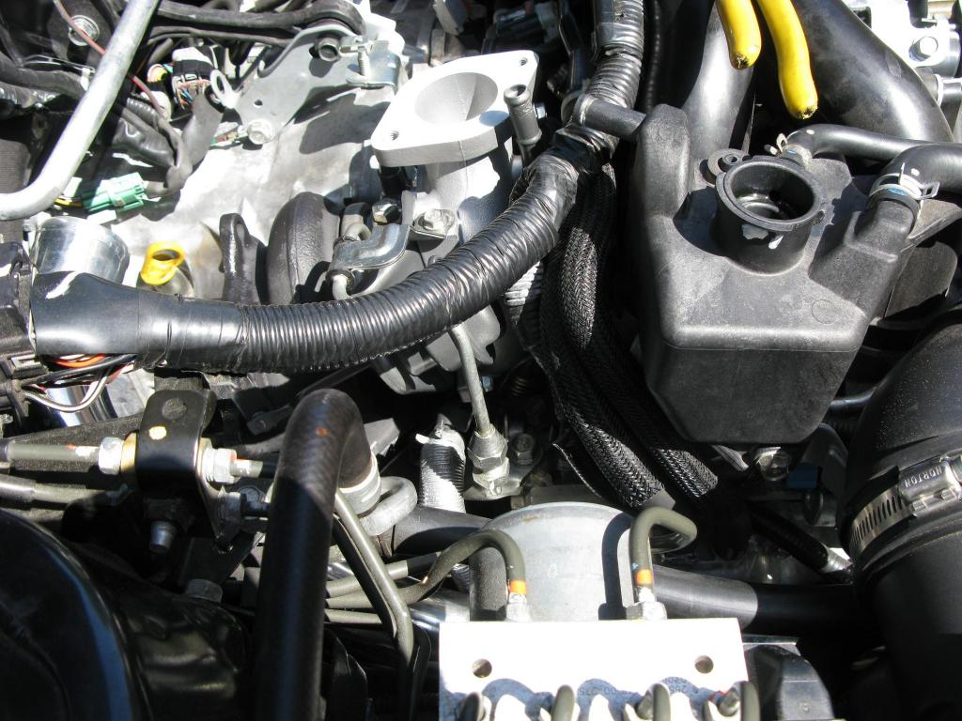
Pic 20=
Another angle.
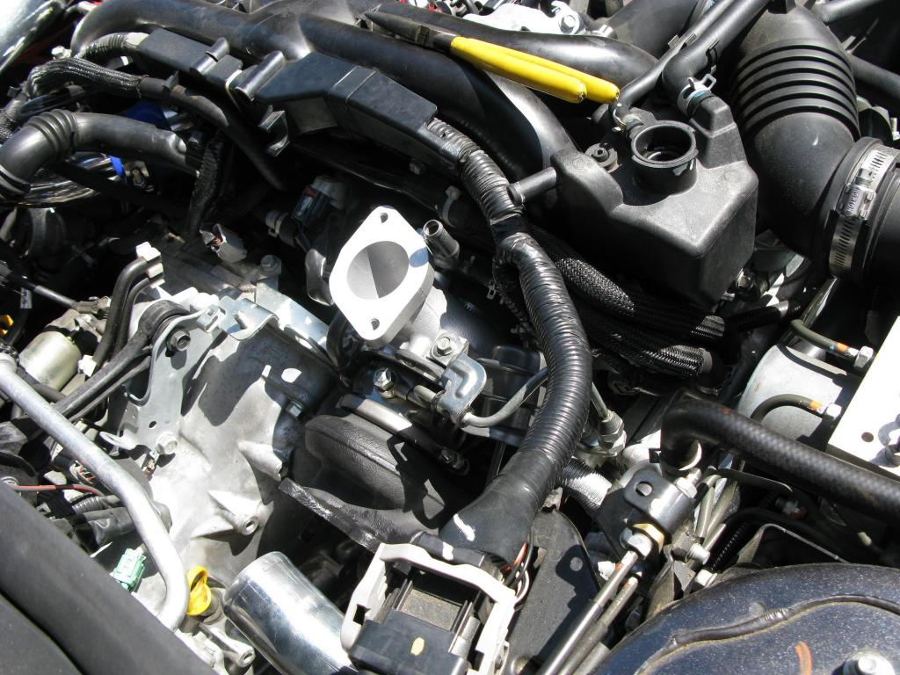
Pic 21=
The coolant supply line installed.
Reconnect the vacuum hoses. Now to reinstall your downpipe. Just reverse the removal procedure. Then reinstall your TMIC/FMIC.
Fill your coolant reservoir over the turbo if you pinched off the hoses. Replace your oil and coolant if you drained it like me.
I remove the fuel pump fuse and turn the engine over a few times to make sure the turbo is primed with coolant and oil. Then I start it up. It will smoke some as the oil residues burn off. Check for leaks. If none you can install your heatshield (after cool down).
I like to drive for 100+ miles in closed loop to "break in" the turbo.


